create war on Jenkins master put war on s3 . In jenkins slave get object war and deploy it using declarative pipeline

-Shweta Raut

Step 1 :configure Jenkins master

Install maven to build the code

Step 2 :configure slave

Install tomcat to deploy webapplication

Step 3 :add IAM role to master and slave ec2 having s3 fullaccess

Step 4 :create pipeline, save it Jenkinsfile and push it to git repo

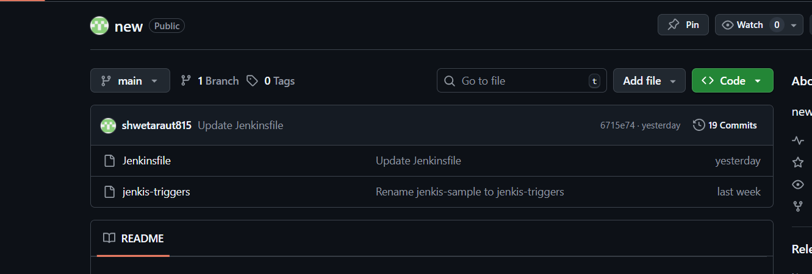

pipeline {

agent {

label{

label 'built-in'

customWorkspace '/project/target/'

}

}

tools {

maven 'maven'

}

stages {

stage("Git Pull") {

steps {

git branch: "master", url: "https://github.com/shwetaraut815/project.git"

}

}

stage("Build") {

steps {

sh "mvn clean install"

}

}

stage("Upload to S3") {

steps {

sh "aws s3 mb s3://war-deploy-3573 "

sh "aws s3 cp target/LoginWebApp.war s3://war-deploy-3573/LoginWebApp.war"

}

}

stage("Clean Old WAR") {

agent { label 'slave-1' }

steps {

sh "rm -f /mnt/server/apache-tomcat-10.1.46/webapps/LoginWebApp.war"

}

}

stage("Download WAR from S3") {

agent { label 'slave-1' }

steps {

dir("/mnt/server/apache-tomcat-10.1.46/webapps") {

sh "aws s3 cp s3://war-deploy-3573/LoginWebApp.war ."

}

}

}

}

}

Step 5 :create pipeline job

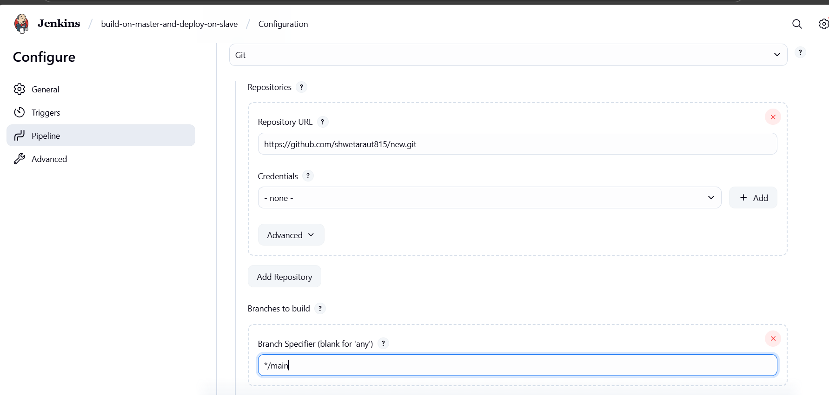

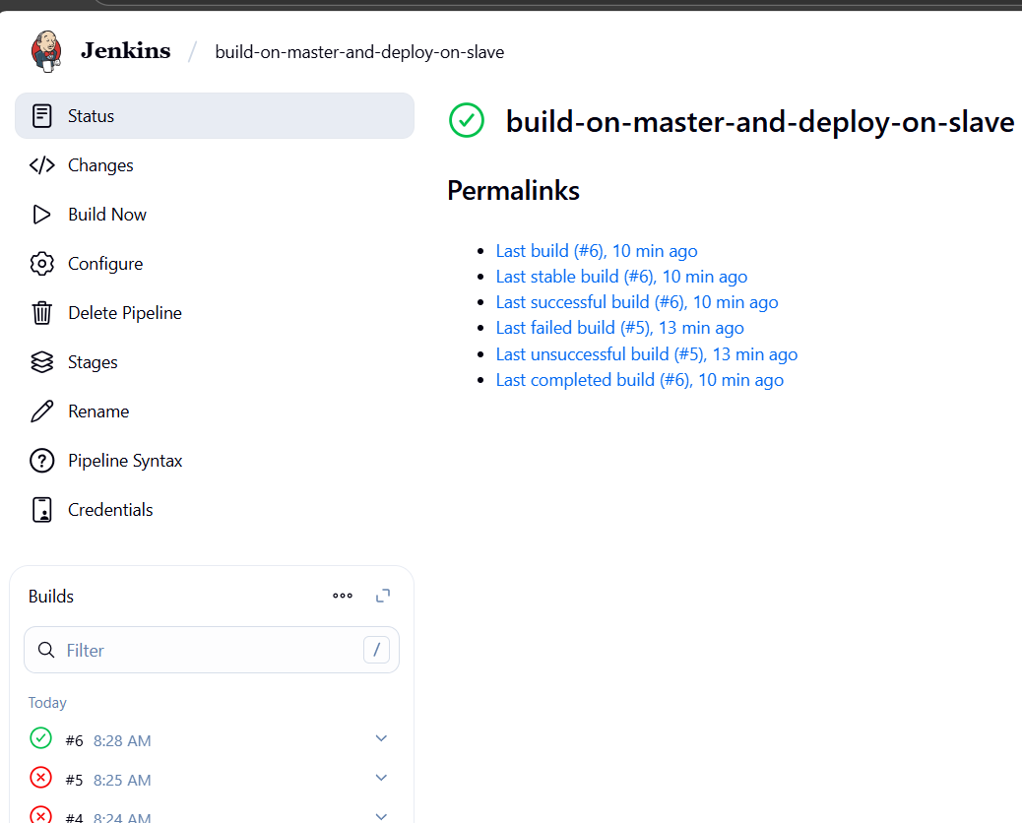

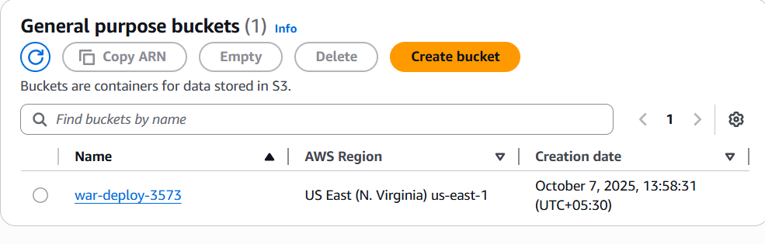

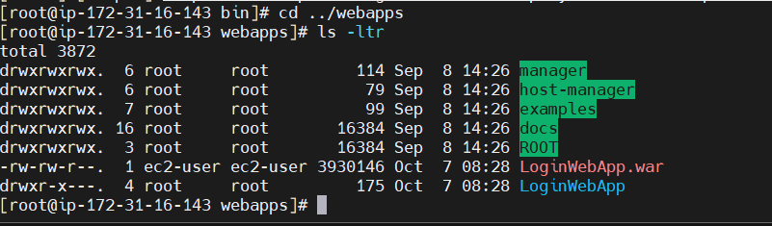

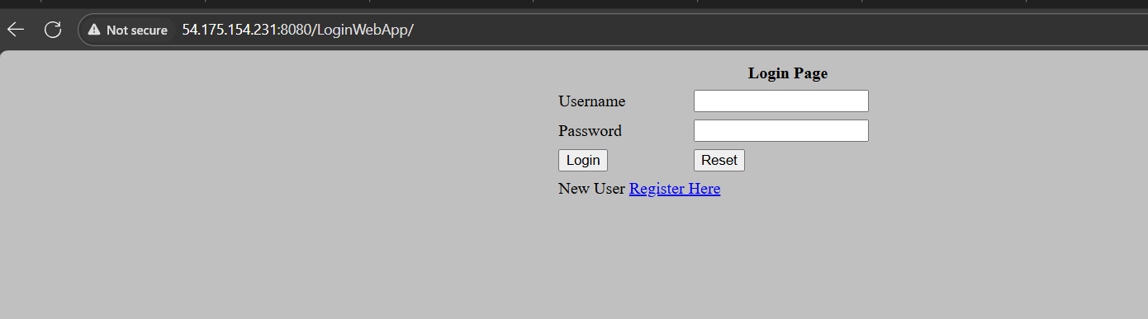

Done!!!!!!!!